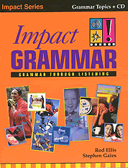
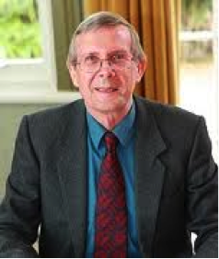

I have been writing and publishing books, both ELT and academic, for some forty years and have worked with more editors than I can recall. Some were excellent and some obstructive and difficult to work with. Michael was one of the excellent ones. I worked with him on four books in the Impact series. His great skill was his ability to give guidance but also a free rein to his writers. I was especially grateful for the detailed comments he gave on specific activities – not just pointing out problems with them but suggesting how they might be overcome.

Michael, of course, was always more than editor. He was a friend to his writers. I remember with the greatest pleasure the visit to his Californian mansion many years ago.

We all gossip in this close-knit field we work in - sometimes maliciously. But I have never heard Michael have a malicious word to say about anybody and I have never heard anyone say anything malicious about him.

Michael is very good at his job and he is a very good person.

Rod Ellis

